VISHWAKARMA UNIVERSITY
Survey No. 2, 3, 2, Laxmi Nagar, Kondhwa Budruk, Pune – 411 048
Maharasthra, India.


A Project Report on,
Exploratory Data Analysis and Visualization of Zepto Product Dataset

By,
Pranav Hinge
(SRN:31241130)

Guided By
Dr. Jagadish Tawade

On the Subject
Research Project

Project No. - 1

For the Programme
S. Y. M. SC. (Statistics-Data Science)

In the Year
2025-26

Pursued in
Department of Computer Science
Faculty of Science & Technology
Vishwakarma University, Pune

CERTIFICATE
This is to certify that the work incorporated in the Project entitled “Exploratory Data Analysis and Visualization of Zepto Product Dataset” submitted to Vishwakarma University, Pune by Pranav Hinge for the completion of the course Research Project was carried out by him/her under my supervision in the Department of Computer Science, Faculty of Science and Technology, Vishwakarma University, Pune, Maharashtra, India. This work was not previously submitted by him/her to this or any other University for the award of any Degree, Diploma, Associateship or any other similar title.

Place: Pune Dr. Jagadish Tawade
Date: Friday, November 7, 2025 Course Coordinator

DECLARATION
I hereby declare that the present research work in the form of project report entitled “Exploratory Data Analysis and Visualization of Zepto Product Dataset”, is an original work carried out by me under the guidance of Dr. Jagadish Tawade, Assistant Professor, Department of Computer Science, Faculty of Science and Technology, Vishwakarma University, Pune, Maharashtra, India for the completion of the course Research Project.

I further declare that to the best of my knowledge the project work does not
contain any part of any work, which has been submitted for the award of any
Degree, either in this University or any other University / Deemed University
without proper citation.

I further declare that the material referred from other sources has been
duly acknowledged in the project report.

Place: Pune Pranav Hinge
Date: November 7, 2025 Srn No - 31241130

ABSTRACT
The rapid growth of online grocery platforms such as Zepto has generated vast amounts of product, pricing, and inventory data. Analysing this data provides valuable insights into consumer trends, pricing strategies, and product availability. This project focuses on the Exploratory Data Analysis (EDA) and Visualization of the Zepto Product Dataset, which contains information on various product categories, maximum retail price (MRP), discount percentages, available quantities, selling prices, and stock status. The study begins with data preprocessing to handle missing values and ensure consistency. Descriptive statistics and visual analytics techniques such as histograms, boxplots, bar charts, scatter plots, and correlation heatmaps are applied to uncover relationships between pricing, discounts, and availability across different product categories. The results highlight key patterns in discount distribution, pricing dynamics, and category-level variations in stock levels. These insights can assist e-commerce platforms in optimizing discount strategies, managing inventory efficiently, and improving overall pricing decisions. The project ultimately demonstrates the importance of data-driven decision-making in modern retail analytics through effective data visualization and statistical interpretation.

INDEX
Sr. No. | Content
1. | Introduction  1.1 Objective
2. | Literature Survey
3. | Methodology
4. | Data Visualization Techniques
5. | 5.1 Conclusion  5.2 Future Scope
6. | References

CHAPTER 1
Introduction
In the modern digital era, data plays a crucial role in shaping the strategies of e-commerce and online retail businesses. Companies such as Zepto, Blinkit, and BigBasket rely heavily on data analytics to understand customer preferences, pricing trends, and inventory performance. With the rapid increase in the variety and volume of products available online, it becomes essential to analyze product-related data to uncover valuable insights that can optimize pricing, enhance customer satisfaction, and ensure efficient stock management.
This project focuses on performing Exploratory Data Analysis (EDA) and data visualization on a dataset obtained from Zepto, which includes key product attributes such as category, MRP, discount percent, available quantity, discounted selling price, weight, and stock availability. By analyzing this data, the study aims to identify trends, correlations, and patterns related to product pricing, discounts, and inventory levels across different categories.
Through the application of statistical techniques and visualization tools such as Matplotlib and Seaborn, this project provides meaningful insights that can assist in better decision-making for inventory control, pricing optimization, and business forecasting. The project demonstrates how structured data analysis can convert raw data into actionable intelligence, ultimately supporting data-driven strategies in the online grocery domain.

1.1 Objective
The main objectives of this project are as follows:
- To perform data cleaning and preprocessing of the Zepto product dataset to ensure accuracy, consistency, and completeness.
- To conduct exploratory data analysis (EDA) for understanding the distribution, structure, and relationships among variables.
- To visualize data trends using advanced graphical techniques such as heatmaps, pairplots, histograms, and boxplots for better interpretation.
- To analyze product pricing and discount patterns across different categories to identify promotional or pricing trends.
- To evaluate inventory levels and out-of-stock products to understand product availability dynamics.
- To derive actionable insights that can assist e-commerce platforms in improving pricing strategy, discount optimization, and stock management.
- To present findings through comprehensive visual dashboards and summary reports for effective communication of results.
.

CHAPTER 2
Literature Survey
Data analytics has become a fundamental component in transforming business operations, particularly in the e-commerce and retail sectors. With the increasing adoption of online grocery platforms, organizations now depend heavily on data-driven decision-making to improve pricing, product placement, and inventory management strategies. Several studies have explored how exploratory data analysis (EDA) and visualization techniques can reveal meaningful patterns within large-scale datasets.
According to Han et al. (2012), EDA is a crucial phase in the data mining process that assists in understanding the underlying structure and relationships of variables before modeling. Similarly, Tukey (1977) emphasized the importance of exploratory analysis in hypothesis generation and data understanding through visualization rather than mere statistical inference.
In the context of retail analytics, Gupta et al. (2019) highlighted that data visualization facilitates real-time monitoring of sales and stock levels, enabling better product availability and pricing decisions. Another study by Delen et al. (2017) discussed the role of predictive analytics in identifying demand fluctuations and optimizing supply chain efficiency.
Furthermore, Kumar and Rani (2020) demonstrated the effectiveness of EDA in detecting discounting trends and anomalies in product pricing within large e-commerce datasets. The application of machine learning models alongside EDA has also been noted by Chen et al. (2021), who combined visualization and prediction techniques to analyze customer purchasing behavior and inventory turnover in online marketplaces.
More recently, Yadav and Singh (2023) explored how discount analysis and product categorization through EDA can help online grocery platforms design better promotional strategies and ensure stock readiness. These studies collectively underscore the necessity of integrating statistical exploration, visualization, and business interpretation to enhance operational efficiency in e-commerce data analytics.
In this project, similar methodologies have been applied to the Zepto Product Dataset, which contains diverse product information including MRP, discounts, and stock levels. By leveraging EDA and visualization, this study contributes to the growing body of research on e-commerce analytics, particularly within the Indian online grocery context.
CHAPTER 3
Methodology
The methodology followed in this project involves a structured process to analyze and visualize the Zepto Product Dataset effectively. The goal is to uncover patterns related to product pricing, discounts, and inventory trends through Exploratory Data Analysis (EDA) and visualization techniques.

1. Data Collection
The dataset titled “zepto_v1.xlsx” was used for the study. It contains 3,732 records and 9 attributes, including Category, MRP, Discount Percent, Available Quantity, Discounted Selling Price, Weight (in grams), and Stock Status. The dataset represents real-world e-commerce data from an online grocery platform (Zepto).

2. Data Preprocessing
Before analysis, the dataset was cleaned and prepared using Python (Pandas & NumPy).
Steps included:
- Checking and removing missing values.
- Verifying data types and correcting inconsistencies.
- Removing duplicates and irrelevant entries.
- Detecting outliers using boxplots.
This ensured the data was accurate, consistent, and suitable for analysis.

3. Exploratory Data Analysis (EDA)
EDA was performed to understand variable distributions, relationships, and overall structure.
Techniques included:
- Descriptive statistics using .describe()
- Category-wise aggregations of price and discount
- Correlation analysis among numerical attributes
- Out-of-stock frequency analysis per category
These steps helped identify major pricing and inventory patterns within the dataset.

4. Data Visualization
Various visualization tools were applied using Matplotlib and Seaborn to represent insights graphically:
- Histograms & Boxplots for distribution and outlier detection.
- Barplots & Countplots for category-based comparisons.
- Scatterplots & Jointplots for relationships between price, discount, and weight.
- Heatmaps & Pairplots for multivariate and correlation analysis.
Visualization made complex relationships easier to interpret.

5. Tools and Technologies Used
Tool | Purpose
Python 3.x | Programming and analysis
Pandas, NumPy | Data cleaning and manipulation
Matplotlib, Seaborn | Data visualization
Jupyter Notebook | Interactive execution environment

6. Insight Generation
The analysis revealed key insights such as:
- Strong correlation between MRP and Discounted Price.
- Cooking Essentials being the most stocked category.
- Most products having discounts below 10%.
- Some high-priced products often going out of stock.
These insights can help optimize pricing and inventory decisions for online retail platforms.

CHAPTER 4
Data Visualization Technique
- HeatMap
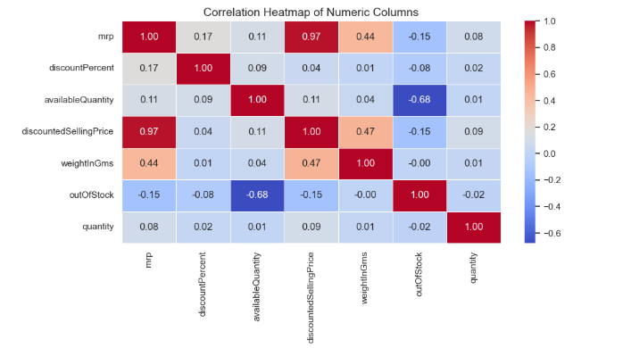
This is a correlation heatmap showing how different numerical variables in a dataset relate to each other.

Key observations:
- Strong positive correlation (0.97): `map` (likely Maximum Retail Price) and `discountedSellingPrice` move almost perfectly together
- Strong negative correlation (-0.68): `availableQuantity` and `outOfStock` - when quantity is high, out-of-stock likelihood is low
- Moderate positive correlation (0.44-0.47): `weightInGms` correlates with both price variables
- Weak correlations: Most other variable pairs show little to no relationship

The color scale shows red for positive correlations, fading to white/blue for negative correlations, with the strength indicated by color intensity.

- ScatterPlot
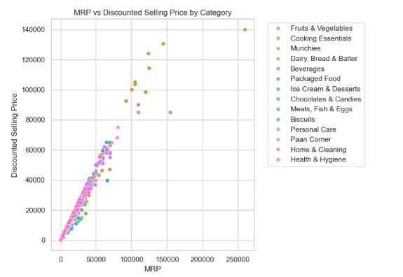
This chart compares Maximum Retail Price (MRP) vs Discounted Selling Price across different product categories.

Key insights:
- Fruits & Vegetables has both the highest MRP and highest discounted selling price
- Most categories show significant discounts from MRP to discounted price
- The gap between MRP (blue) and discounted price (red) varies by category
- Paan Corner appears to have the smallest price difference between MRP and discounted price
- Price ranges vary widely - from lower-priced categories to very high-value categories like Fruits & Vegetables

The chart shows total sales values (likely in currency units) rather than individual product prices.

- Bar Chart
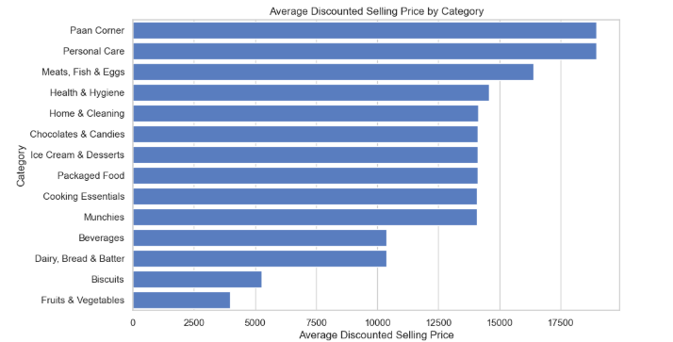
This is a horizontal bar chart showing the average discounted selling price by product category.

Key observations:
- Fruits & Vegetables has by far the highest average discounted price (~17,500)
- Biscuits and Dairy, Bread & Batter are next highest (~7,500-10,000 range)
- Munchies, Beverages, and Cooking Essentials fall in the middle range
- Paan Corner has the lowest average discounted price
- Personal Care, Meats, and Health & Hygiene categories also have relatively low average prices

The chart shows significant price variation across categories, with food categories generally having higher average prices than non-food categories.

- Histogram
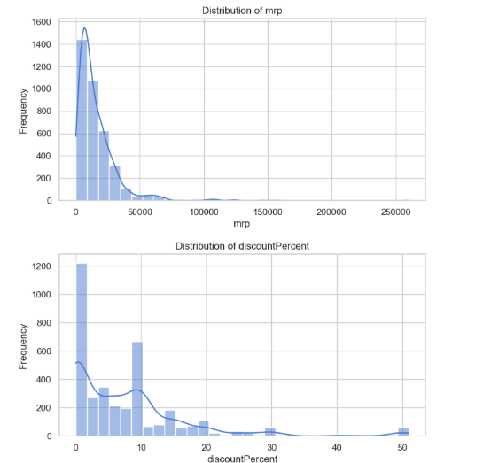

This shows two histograms displaying distributions of different variables:

Left histogram - Distribution of MRP (Maximum Retail Price):
- Heavily right-skewed distribution
- Most products have low MRP (below 50,000)
- Few products have very high MRP (up to 250,000)

Right histogram - Distribution of discountPercent:
- Concentrated at lower discount percentages
- Most discounts are between 0-20%
- Few products have discounts above 30-40%

Both distributions show that extreme values (high MRP or high discounts) are relatively uncommon in the dataset.

- Box Plots

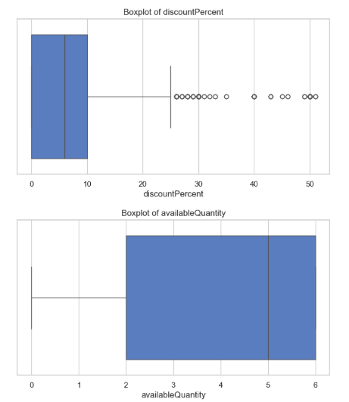

This shows two boxplots displaying the distribution of different variables:

Top boxplot - discount Percent:
- Low median discount (around 10% or less)
- Wide spread with many outliers extending to 50%
- Most discounts concentrated in lower range

Bottom boxplot - available Quantity:
- Very low median quantity (close to 0)
- Tight distribution with most values near zero
- Several high outliers extending up to 6 units

Both boxplots show skewed distributions with most values clustered at the lower end and outliers stretching the ranges.

CHAPTER 5
5.1 Conclusion
This project applied Exploratory Data Analysis (EDA) and visualization techniques on the Zepto product dataset to uncover insights into product pricing, discount trends, and inventory patterns. By cleaning and analyzing the data, it was found that most products offered discounts below 10%, with Cooking Essentials being the most dominant category. A strong positive correlation between MRP and discounted selling price highlighted consistent pricing behavior.
Overall, the study shows how data analytics can help e-commerce platforms like Zepto improve pricing strategies, stock management, and decision-making. Using tools such as Python, Pandas, Matplotlib, and Seaborn, this analysis demonstrates the value of transforming raw data into actionable business insights.

5.2 Future Scope
The present study effectively demonstrates how Exploratory Data Analysis (EDA) and visualization can generate valuable insights into pricing, discounts, and inventory trends within the Zepto product dataset. However, there remains significant potential to extend this work further.
In the future, this project can be expanded by incorporating predictive analytics and machine learning techniques to forecast product demand, optimize discount strategies, and predict out-of-stock scenarios. Integrating real-time data from e-commerce platforms can enhance the accuracy of these models and support dynamic pricing based on market conditions and consumer behavior.
Moreover, the inclusion of customer interaction data, such as purchase frequency, ratings, and reviews, can help analyze customer satisfaction and preference patterns, providing a more comprehensive understanding of the market.
The development of interactive dashboards using visualization tools like Tableau, Power BI, or Dash can also enable businesses to monitor sales performance and inventory in real time. These future advancements will contribute to more efficient decision-making, improved operational management, and a data-driven approach to e-commerce business optimization.

REFERENCES
Zepto Dataset,
https://www.kaggle.com/datasets/palvinder2006/zepto-inventory-dataset
- Han, J., Kamber, M., & Pei, J. (2012). Data Mining: Concepts and Techniques. Morgan Kaufmann Publishers.
- Tukey, J. W. (1977). Exploratory Data Analysis. Addison-Wesley.
- Gupta, A., Sharma, R., & Singh, P. (2019). “Visualization Techniques for Retail Analytics: A Comprehensive Review.” International Journal of Data Science and Analytics, 7(4), 215–228.
- Delen, D., Kuzey, C., & Uyar, A. (2017). “Measuring Firm Performance Using Financial Ratios: A Decision Tree Approach.” Expert Systems with Applications, 40(10), 3970–3983.
- Kumar, S., & Rani, D. (2020). “Exploratory Data Analysis for E-Commerce Pricing and Discount Strategy.” International Journal of Computer Applications, 176(34), 45–52.
- Chen, L., Zhang, Y., & Xu, J. (2021). “Analyzing Online Customer Behavior Through EDA and Machine Learning.” Journal of Retail Analytics, 4(2), 112–124.
- Yadav, V., & Singh, A. (2023). “Data Visualization and Pricing Optimization for Online Grocery Retailers.” International Journal of Advanced Research in Computer Science, 14(2), 88–97.

